Fontys University Of Applied Sciences

MusicMaven

Web Application

Project plan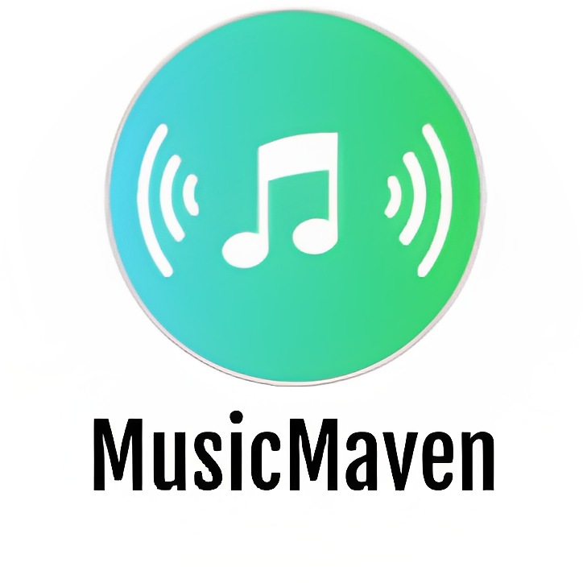

*Software Engineering*

**Author:**

Martin Hristev

*Version: 0.1*

Eindhoven

**2 0 2 3**

Table of Contents

**1. Project Overview** **3**

**2. Project Goal** **3**

2.1 Web application 3

2.2 Desktop Application 4

**3. Deliverables** **4**

**4. Stakeholders** **4**

**5. Team** **4**

**6. Risk management** **5**

**7. Communication Plan** **5**

**8. Project timeline** **5**

**9. Conclusion** **6**

# 

# 

# 1. Project Overview

MusicMaven is a web-based social platform that brings together music lovers from all over the world. It is designed to provide a platform for individuals to share their opinions and thoughts on the latest album releases, songs, and artists. In addition to the web platform, MusicMaven will also have a desktop application for administration purposes.

# 2. Project Goal

## 2.1 Web application

The objectives of the web application are to:

* Provide personalized review system for users to rate and share their opinions.

The review system will be personalized to each user, allowing them to create reviews and share their opinions on the latest music releases. Users will be able to rate albums, songs, and artists on a scale of 1 to 10 stars and leave description to explain their rating.

* Allow users to follow other music lovers and stay updated with their latest reviews and recommendations.

Users will be able to follow other users on the platform and receive updates when they post new music reviews and recommendations.

* Enable users to engage with the community by liking and commenting on reviews.

Users will be able to engage with other users by liking and commenting on reviews. This will create a sense of community on the platform and encourage users to share their opinions.

* Provide a music discovery feature that allows users to explore popular reviews and recommendations from the community, even without logging in.

Users will be able to explore popular reviews and recommendations from the community without the need to log in to the platform. This will allow new users to get a sense of what the platform is about before they sign up.

* Integrate with Spotify API to generate a random playlist based on user input.

Users will be able to input their favorite artist/genre/song, and the platform will generate a playlist based on their input. This feature will allow users to discover new music based on their preferences.

## 2.2 Desktop Application

The final version of the product will also have a desktop application for administration purposes.It will enable the administrator to manage user accounts, add new albums, artists, and songs to the platform, and perform other administrative tasks.

# 3. Deliverables

* Design and develop a web-based social platform with key features.
* Desktop application for administration purposes.
* Account management (user login and registration).
* Personalized review system that allows users to rate and share their thoughts on albums, songs, and artists.
* Ability for users to follow other music lovers and stay updated with their latest music reviews and recommendations.
* Engaging with the community by liking and commenting on reviews.
* Feature that allows users to explore popular reviews and recommendations from the community.
* Integration with Spotify API to generate a random playlist based on user input.

# 4. Stakeholders

The stakeholders for this project are primarily music lovers who are interested in sharing their thoughts and opinions on the latest album releases, songs, and artists. The secondary stakeholders are the project tutors, who will provide feedback on the platform's design, functionality, and features throughout the development process.

# 5. Team

Project owner and developer: Martin Hristev

# 6. Risk management

* Technical issues: The project tutors will regularly test the platform and address any technical issues that arise.
* Time management: Poor time management will lead to project delays.

# 7. Communication Plan

* Feedback from tutors will be incorporated into the project at regular intervals.
* The project will be divided into small milestones and at the end of each milestone, progress will be presented to the tutors.

# 8. Project timeline

* ***Week 1-2: Research and planning***

The developer will conduct research on similar platforms and plan the features and design of the MusicMaven platform by submiting an Ideation document.

* ***Week 3: Documentation***

The developer will deliver Project Plan, URS, Test Plan and UML class diagram.

* ***Week 4-5: Front-end development***

The developer will create the front-end of the platform using HTML, CSS, and JavaScript for the Web application and the GUI for the Desktop application.

* ***Week 6-12: Back-end development and database integration.***

The project owner will develop the back-end of the platform using .NET and C# and will start the integration of the MSSQL database.

* ***Week 13-14: Integrating with Spotify API***

The developer will integrate the platform with Spotify API to generate a random playlist based on user input and build additional UI for the additional features.

* ***Week 15-16: Testing and debugging***

The developer will test the platform and debug any issues that arise.

* ***Week 17-18: Deployment and launch***

The developer will deploy the platform to a web server and launch it for public use.

# 9. Conclusion

The MusicMaven web platform aims to provide a personalized, interactive, and engaging experience for music lovers from all over the world. The platform will enable users to share their opinions and thoughts on music with a community, discover new music, and get recommendations from other users. The integration with Spotify API will add an additional level of functionality to the platform. The Desktop application for the MusicMaven will be mainly for administration purposes. The project tutors will monitor the development of the platform and make any necessary adjustments.

# 